Nutrition Ed.
REC SOCIAL IN SITE ACTIVITY HEALTH PROMOTION COUNSELING

TERRIFIC, Inc.

Main Office:
1438 Kennedy Street, NW 20011
Phone: 202 882-1160
www.terrificinc.org
 | CLARIDGE TOWER MAY 2022 ACTIVITY CALENDAR
 | MONDAY | TUESDAY | WEDNESDAY | THURSDAY | FRIDAY
 | 2  10:00 am Welcome  Health Promotion  Games with Dennis (Virtual)  11:00 am Arts & crafts  12:00 pm Lunch  1:00 pm TERRIFIC Taste | 3  10:00 am Welcome  Health Promotion  11:00 Music Appreciation  12:00 pm Lunch  1:00 pm TERRIFIC Taste | 4  10:00 am Welcome  Games with Dennis (Virtual)  11:00 am Chat and Chew  12:00 pm Lunch  Health  1:00 pm TERRIFIC Taste | 5  10:00 am Welcome  Health Promotion  11:00 am Enrichment. Activity  12:00 pm Lunch  1:00 pm TERRIFIC Taste | 6  10:00 am Welcome  Health Promotion  Games with Dennis (Virtual)  11:00 am Arts & crafts  12:00 pm Lunch  12:30 Story Telling  Discussion  1:00 pm TERRIFIC Taste
 | 9  10:00 am Welcome  Health Promotion  Games with Dennis (Virtual)  11:00 am Trivia  12:00 pm Lunch  1:00 pm TERRIFIC Taste | 10  10:00 am Welcome  Health Promotion  11:00 am Arts and Crafts  12:00 pm Lunch  1:00 pm TERRIFIC Taste | 11  10:00 am Welcome  Health Promotion  Games with Dennis (Virtual)  11:00 am Trivia  12:00 pm Lunch  1:00 pm TERRIFIC Taste | 12  10:00 am Welcome  Health Promotion  11:00 am Brain Teasers  12:00 pm Lunch  1:00 pm TERRIFIC Taste | 13  10:00 am Welcome  Health Promotion  Games with Dennis (Virtual)  11:00 am Commonyms  12:00 pm Lunch  1:00 pm TERRIFIC Taste
 | 16  10:00 Welcome  Health Promotion  11:00 am Commonyms  Games with Dennis (Virtual)  11:30 am Tech Training w/ Jonathon (In- Person)  12:00 pm Lunch  1:00 pm TERRIFIC Taste | 17  10:00 am Welcome  Health Promotion  10:30 am Dollar Tree Visit  11:00 am Brain Teasers  12:00 pm Lunch  1:00 pm TERRIFIC Taste | 18  10:00 am Welcome  Health Promotion  11:00 am Music Appreciation  Games with Dennis (Virtual)  12:00 pm Lunch  1:00 pm TERRIFIC Taste | 19 10:00 am Welcome  Health Promotion  10:30 am Amish Market Visit  11:00 am Enrichment. Activity  12:00 pm Lunch  1:00 pm TERRIFIC Taste | 20  10:00 am Welcome  Health Promotion  Games with Dennis (Virtual)  11:00 am Arts & crafts  12:00 pm Lunch  Chat/Chew-  1:00 pm TERRIFIC Taste
 | 23  10:00 am Welcome  Games with Dennis (Virtual)  11:00 am Mindfulness  11:30 am Older American Appreciation  12:00 pm Lunch  1:00 pm TERRIFIC Taste | 24  10:00 am Welcome  Health Promotion  11:00 am Word Search/  Chat and Chew  12:00 pm Lunch  1:00 pm TERRIFIC Taste | 25  10:00 am Welcome  Health Promotion  Games with Dennis (Virtual)  11:00 am Tech Training (In Person)  12:00 pm Lunch  1:00 pm TERRIFIC Taste  *Senior Fest/Picnic* | 26  10:00 am Welcome  Health Promotion  11:00 am Enrichment. Activity  11:30 am Older American Appreciation  12:00 pm Lunch  1:00 pm TERRIFIC Taste | 27  TERRIFIC Inc:  Annual Older Americans Appreciation Day  * Virtual Event 10:00 am – 2:00 pm
 | 30  10:00 am Welcome  Health Promotion  Games with Dennis (Virtual)  11:00 am Arts & crafts  12:00 pm Lunch  1:00 pm TERRIFIC Taste | 31  10:00 am Welcome  Health Promotion  11:00 Music Appreciation  12:00 pm Lunch  1:00 pm TERRIFIC Taste |  | 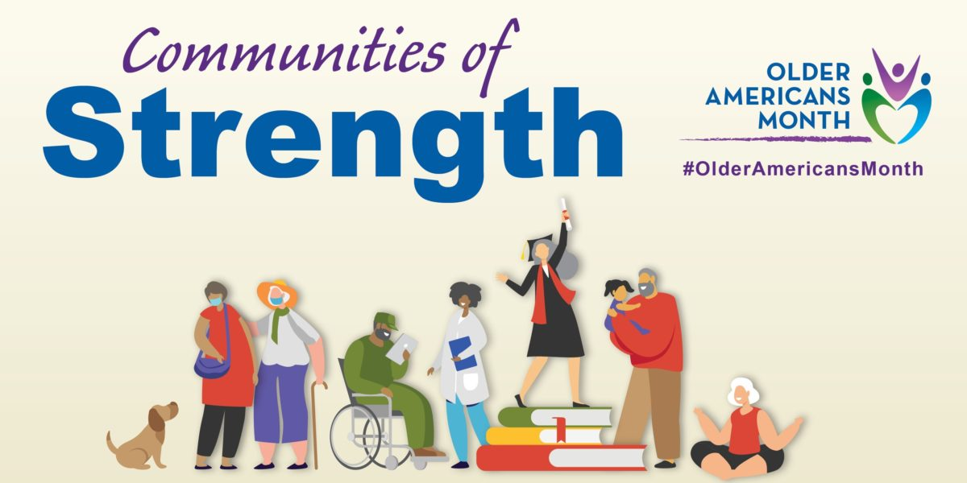 | 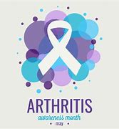
Events in May: Older Americans/Arthritis Month

